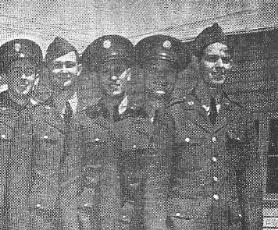
“2Lt. John A. Podawiltz Killed in Action in Burma, November 11”
Word has just been received here that Lieutenant John A. Podawiltz, son of Mr. and Mrs. A.J. Podawiltz, former residents of Eau Claire and now living at 320 Grand Boulevard East, Detroit, Michigan, was killed in action at Kyaukse, Burma, on Armistice Day, November 11, while piloting a 4-motor B-24 bomber.
Lieutenant Podawiltz enlisted in July 1941 and received his basic training at Chanute Field.
Lieutenant Podawiltz was one of ten Air Corps soldiers at the Enid Army Flying School, Enid, OK selected from the enlisted ranks to become aviation cadets.
Lieutenant Podawiltz is second from the right in the above picture of a group of five of these men.
